Version 1.0

Revision History

|  |  |  |  |
| --- | --- | --- | --- |
| **Date** | **Version** | **Description** | **Author** |
| 02/12/2019 | 1.0 | details | Pham Thi Hong Trang |
|  |  |  |  |
|  |  |  |  |
|  |  |  |  |

Table of Contents

1. Introduction 4

1.1 Purpose 4

1.2 Scope 4

1.3 Definitions, Acronyms, and Abbreviations 4

1.4 References 4

1.5 Overview 4

2. Business Use-Case Name 4

2.1 Brief Description 4

3. Goals 4

4. Performance Goals 4

4.1 <name of performance goal> 5

5. Workflow 5

5.1 Basic Workflow 5

5.1.1 <name of workflow step> 5

5.2 Alternative Workflows: Still achieve success but in different way 5

5.2.1 <name of workflow step> 5

6. Risk 5

7. Possibilities 5

8. Process Owner 5

9. Special Requirements 5

9.1 <Name of Special Requirement 1> 5

9.2 <Name of Special Requirement 2> 5

10. Extension Points 6

10.1 <Name of Extension Point> 6

Business Use-Case Specification: <Manage Order>

# Introduction

## Purpose

The purpose of this business use-case is to show how to manage order of the computer shop when manager deal with problems happens related order

## Scope

The scope of this business use-case is associated with the computer shop to be deployed

## Definitions, Acronyms, and Abbreviations

Manager: admin

## References

TBD

## Overview

The rest of the Business Use-case Specification contains goal, risk, process owner and special requirement

# Business Use-Case Name

## Brief Description

The use-case here is that “Manage Order”, which means the managers have to deal with all problems related to order of the online shop.

# Goals

The goal of the business use-case is to help admin managing order: update order or delete order.

# Performance Goals

## Manager can update order

When customer has order, but they have some problems related to information of order so the manager can update the information of order.

## Manager can delete order

When customer have e request that they want to cancel order, manager can delete order.

# Workflow

The customer order computer. After ordering, our staff have some contacts to check about order’s customer. If it has some problem, customer have request for manager to update order and go to delivery step. If customer have request that they want to cancel order, manager will delete order getting out computer shop system.

## Basic Workflow

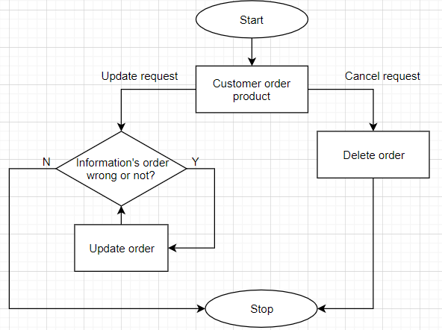

# Risk

No special.

# Possibilities

No special.

# Process Owner

The process owner if this usecase is the administrator or can be called manager of the computer shop who deal with the situation.

# Special Requirements

No special.

# Extension Points

No extension points.